**Risk Matrix**

*Project Risk Matrix*

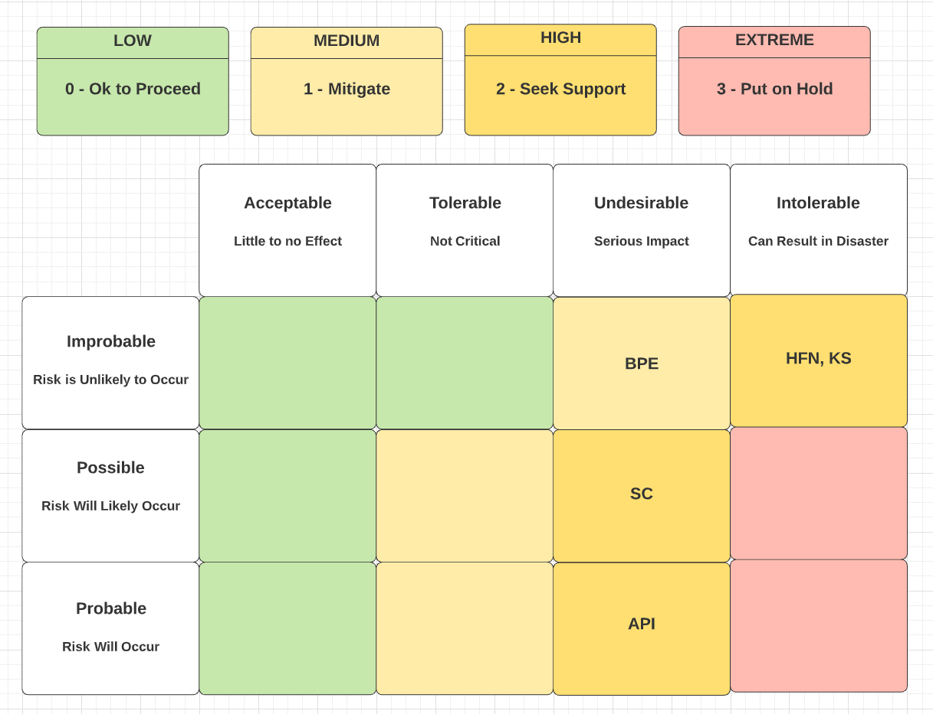

API risk: API Bugs. Flaws within the API are to be expected but with thorough unit and integration testing in addition to defensive programming practices, the probable and undesirable risk can be reduced. Engineers can program defensively by first accepting that errors will arise and then writing code to combat them when they do happen. Also implementing pre- and post-conditions defends against unsafe inputs and outputs. Moreover every function should exhibit a single responsibility and be paired with tests validating the declared responsibility. Thereafter once the smart contract is built, integration testing should occur.

SC risk: Incorrectly written smart contract. Developers without previous exposure to blockchain smart contracts may codify flaws in the contract possibly leading to serious impact. However IBM does provide documentation for creating smart contract projects to assist novice blockchain developers. The IBM Blockchain Platform VS Code extension also comes with smart contract template types. A default contract illustrates how to perform CRUD operations to the ledger shared by the blockchain business network members. Additionally there is a private data contract template that showcases CRUD operations to a collection (for a single network member).

HFN, BPE, and KS risks: Unknown Issues in the Hyperledger Fabric Network, IBM Blockchain Platform extension, and IBM Kubernetes service. The likelihood of unknown issues severely derailing the project is improbable. The software is frequently monitored for issues and IBM has the capacity to address them and inform developers of workarounds and patches. Yet, if issues were to occur they could slow down or completely block project execution and delivery. If the Kubernetes service fails to remain a viable solution, another cloud provider can be selected to host the blockchain network.